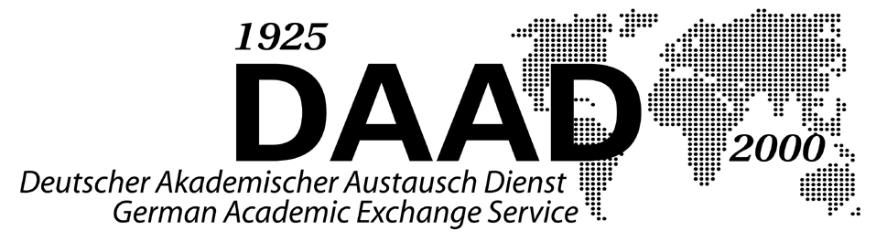

Applicant Information for the DAAD/OSI Program

The German Academic Exchange Service (DAAD), Bonn, and the Open Society Scholarship Programs are collaborating on a joint program of grants for graduates from the selected countries in Central Asia,, the Former Soviet Union and the Balkans.

- Aim

The DAAD/OSI Scholarships aim to bolster the capacity of the participating countries to provide quality instruction and research in the social sciences and humanities, and to create a network of scholars from these countries in these fields with colleagues in Germany to enhance the international exchange of ideas and academic best practice.
A variety of academic opportunities are available to scholars in participating countries to pursue advanced degrees and training at top level universities in Germany. Grantees will be clustered at host institutions to build cohorts of graduates and professors with a common frame of reference, generating international and intra-regional connections into the future.

The grants are awarded jointly by DAAD and Open Society Foundations for study and living expenses incurred at German Universities.

The Program is open to scholars from the following countries in 2010-11:

  - Azerbaijan
  - Georgia
  - Turkmenistan
  - Uzbekistan
  - Belarus
  - Moldova
  - Ukraine
  - Albania
  - Bosnia & Herzegovina
  - Croatia
  - Kosovo

- Target Group

The grants are aimed at students with either a Bachelors degree or a Masters degree or who have completed 5 years of a diploma.

- Eligible Pathways

Grants are issued for one of the following options:

- Masters’ level studies (2 years) – more information is available in the Course List.

- Doctoral studies (3 years) - Ph. D. students will be based at a German university for at least 3 years. Doctoral studies in Germany do not have taught courses as such, but offer close mentoring by an academic supervisor on a selected topic. Extension of the scholarship beyond three years will be contingent upon positive annual reviews and the recommendation of the faculty mentor.

- Eligible Courses

Applicants for the Masters pathway can apply for one of the courses in the Course List.

Students interested in the PhD option can apply for studies within the following areas:

- Political Science
- Sociology
- German Studies
- International Relations
- Law
- Economics
- Public Administration Studies
- Educational Administrative Studies
- Public Health
- Philosophy
- Peace and Conflict Resolution Studies

Under certain circumstances, other courses within the realms of the social sciences and humanities can be considered. The list represents fields of social sciences and humanities underrepresented in the participating countries and available in either English or German instruction at German universities.

- Application Requirements

All applicants must apply within one of areas mentioned in point 3 above.

- Masters Courses (2 Years)

Students can submit applications when they are still finishing their Bachelor studies, but have to have their BA diploma before they start their academic studies at a university in Germany.

- Doctoral Studies (3 Years)

Applicants must have a further university diploma, normally a Masters degree. In specific cases, applications are permitted after 5 years of undergraduate study when a specialisation has been outlined by the applicant.

In addition, the applicant should already be in the first or second year of teaching. The theme of the proposed work should be confirmed as academically sound from the home university. All applicants must provide evidence of contact to a prospective German supervisor.

- Language Competence

A good knowledge of German is mandatory, and will be tested upon application. Improvement of the applicant’s competence in German is facilitated through a 2 month language course in the home country before the commencement of the scholarship. If necessary, Masters’ grantees can do a further 2 month language course in Germany before the scholarship is taken up.

Please note that no equivalent language training will be offered in English.

If necessary, German language competence tests (DSH) take place for all Masters and PhD candidates from each country. Information regarding testing locations is available from local DAAD representatives at DAAD-IC offices.

Applicants wishing to follow a course instructed in English are required to have a very good command of the English language, proven by a TOEFL test.

- Grantee Selection

Selection Committee

The selection committee comprises 2 German university lecturers, a DAAD and OSF- London representative as well as 2 local university lecturers, who, if possible, should be former DAAD grantees or fully qualified researchers supported by DAAD.

Decisions surrounding academic capabilities, the study preferences of the applicants/their capacity for feasible doctorial studies will be made by the German university lecturers alone.

Selection Procedure

Written applications will be collected up to the generic deadline of the 15th November 2010 by German Embassy in Croatia directly (see the Contact List).

German language tests will be administered by the local DAAD-IC office representative, which will take place on one date only (normally in December).

In January or February of the following year, selection committees and interviews will commence for all applicants.

Selection Criteria

Selection will be based on academic merit, knowledge of the language required, extracurricular activities, and leadership potential, and will follow a multi-tiered and transparent process. All completed applications will be reviewed and evaluated by selection teams representing the universities, DAAD and OSF- London..

Semi-finalists will be invited for an in-country interview in January and February, an academic examination by the committee for Ph.D. candidates, and to sit a German or English language exam. Final decisions will be made by the selection committee in Bonn.

The interview will primarily be carried out in German, but can also be conducted in English.

All applicants must be aware that after a 2-4 month language course, an adequate level of German must be demonstrated in order to fulfil all necessary academic requirements.

- Costs Covered

DAAD/OSI Scholarships are in essence full scholarship awards, which include a monthly stipend sufficient for a singe person, one return trip (PhD scholars get an additional return trip to their home country in the 2nd year of study), pre-sessional language training where necessary, and scholarship enhancement activities, including an Orientation Event, taking place in Bonn in October each year, as well as a Mid Year Conference held at a German University.

Costs or supplements for partners or children are not covered by the Program.

- Advice and Information

For contacts in Croatia, please see special document “Contacts for Advice and Information” on the DAAD/OSI competition announcement web page on www.stipendije.info.

- Application Forms

Applicants should apply on the usual DAAD application forms submitting all necessary documents requested on page 5 of the DAAD Application Form (Antrag auf ein Forschungs-/Studienstipendium) (green) along with 2 Reference Forms (Gutachten zu Stipendienanträgen von ausländischen Studierenden,Graduierten, Doktoranden und Promovierten), available from German Embassies and Consulates, local DAAD Lecturers in country, and also through the following link www.daad.de/de/form.

- Application Details

Applicants falling under points 4a or 4b above should provide the following information, as demanded by DAAD regulations: the green Application Forms, CV, research plan or study motivations, proof of contact to a German University (necessary for 4a only), confirmation of supervision (for 4b only), timetable (for 4b only), 2 references from professors at the home university, certified copies of A-level, Bachelor and/or Masters’ certificates, or if in the 4th year of study, a certified copy of the course certificates gained so far, as well as a DAAD Language certificate.

Copies of the certificates and their translations must be certified.

A medical report need only be submitted after the Award has been granted.

