MTEC Public Administration

University of Twente



FULL MTEC SCHOLARSHIPS

for students from:

Albania, Belarus, Bosnia and Herzegovina, Bulgaria, Croatia, Jordan,
Macedonia, Moldova, Montenegro, Morocco, Romania,
Russian Federation, Serbia, Turkey and Ukraine.

For the academic year 2008 - 2009


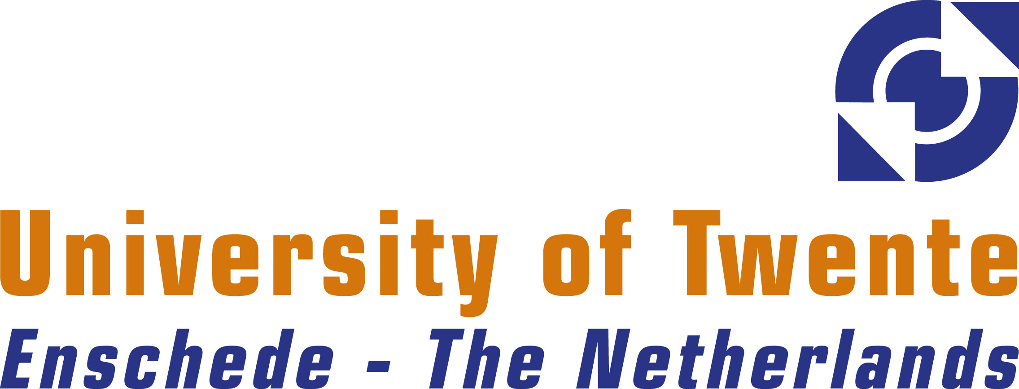
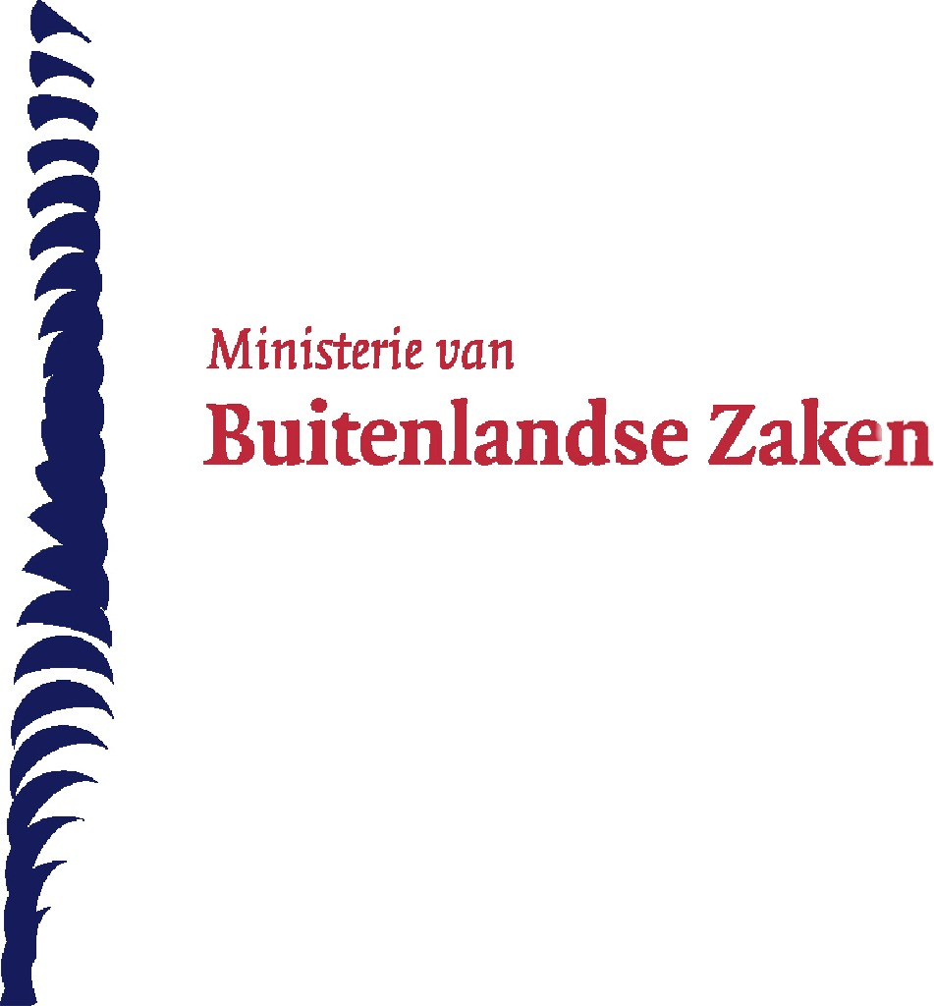
MTEC Scholarships Public Administration
Full scholarships are made available by the Netherlands Ministry of Foreign Affairs for study at University of Twente for students enrolling in the upcoming academic year 2008 / 2009.

Purpose of the MTEC Scholarships
The MTEC scholarships are intended for promising students from the countries which will become a member of the European Union in the near future, the (potential) candidate countries of the European Union and those countries which border the extended Union both in the East and in the South. In this way the Netherlands wishes to contribute to the enhancement of strategic cooperation and partnerships on the basis of the core values which are shared by the EU.

What does an MTEC Scholarship consist of?
An MTEC scholarship covers tuition fee, study materials, housing, subsistence, insurance, visa costs, travel to and from the home country, a personal development programme (including effective leadership, change management, project planning) and a social programme (Introduction programme, excursions, and access to the unique campus facilities of the University of Twente).

Who may apply for an MTEC scholarship?
The MTEC scholarships are meant for students and civil servants of the aforementioned countries listed on the front page, who completed their BSc with flying colours and who satisfy the criteria for admission to the MSc Public Administration, University of Twente. Applicants should both be nationals of one of the participating countries and be resident in one of these countries. A selection procedure is part of the intake.

Preconditions
Prospective students need to have completed a bachelor degree in Public Administration or strongly related social sciences, live in the relevant states at the time of application, have an IELTS score of 6.0 average, and not be older than 35 years.

The MTEC scholarships are intended for promising students and also for workers in the field of Public Administration, that is, those who have completed their BSc and have already started their career in a relevant field of work. Professionals are required to acquire permission of their employer to study a year abroad and be issued with a guarantee that they can take up their position upon return.

The MSc programme Public Administration
The Public Administration (PA) Master’s degree programme, duration one year, highlights public administration and informed approaches (i.e. rooted in policy) to social issues. As a public administrator, you will be expected to understand the complex administrative relations in networks of public and private organisations and their impact on the quality of administration and policymaking. In addition, you must be able to systematically analyse the implications for various values and interests involved and the tension arising between such concerns as decisiveness and democracy. To effectively evaluate problems and design appropriate solutions, you must have the ability to assess existing knowledge at face value and generate new, relevant knowledge. Moreover, you will be able to use that knowledge as a basis for effective recommendations and their introduction/implementation.
After completing the Public Administration Master’s degree programme, you will have acquired:
- insight into the complex, intricately interwoven relations of governance networks and their impact on the quality of administration and policymaking;
- the ability to (normatively) reflect on the dimensions of quality in administration and policy;
- the ability to critically assess existing knowledge;
- the ability to translate knowledge into recommendations and designs;
- the ability to generate relevant knowledge (i.e. how to formulate a research assignment, how to monitor the implementation of a research project, how to transform research findings in practical recommendations);
- the ability to (somewhat independently) conduct practice-oriented research.

Location
With ample 40 years of age, the University of Twente is a young institute with little over 8.000 students, half of whom study at undergraduate level. Our education is consistently ranked in the top 3 in the Netherlands. The only university in the Netherlands that features a residential campus, Twente offers these students an environment that emphasizes shared experience. The 346 acres campus provides an academic and social setting that invites students to quickly become active members of a thriving community. Extensive sporting facilities, film and music studios, stages and more, are run by a very active and professional Student Union.

Application
Candidates should apply through the website of EVD/CROSS (www.cross-agency.nl) and consecutively send their printed application form to the Royal Netherlands Embassy in their country. Applicants who want to be considered for an MTEC Scholarship have to go through the regular admission procedure of the University of Twente (see graduate.utwente.nl). Applicants, who have already been admitted to the MSc programme Public Administration of University of Twente, can directly apply for an MTEC scholarship by using the application form which is available at the website of EVD/CROSS.

Applications for admission for the academic year 2008/2009 should be sent before the 1st of July 2008.
More information
For more information about the MSc programme Public Administration, please visit pa.graduate.utwente.nl or contact the study information desk at master@utwente.nl or telephone (+31) 53 489 5489. For more information about University of Twente, please visit www.utwente.nl/en. For more information about the MTEC scholarships, including conditions regarding application and the entitlements and obligations which are attached to the scholarships, and the application form, please visit: www.cross-agency.nl or contact Mr. Diederik ter Haar by e-mail (crossonline@info.evd.nl) or telephone (+31 70 778 81 39).

University of Twente EVD
School for Business, Public Administration Matra Training for European Cooperation
and Technology
P.O. box 217 P.O. Box 20105
7500 AE Enschede 2500 EC The Hague
The Netherlands The Netherlands
www.smg.utwente.nl www.cross-agency.nl
Application form at:
pa.graduate.utwente.nl

